**SOUTHERN RIVER COLLEGE**

**Human Biological Science**

**Unit 3 & 4**

**TASK 9 – Test 4**

**Evolution**

**Time: 60 mins**

Multiple Choice: 10 marks

Short Answer: 30 marks

Extended Answer: 10 marks

TOTAL 50 MARKS

**Weighting: 5%**

**Do not write on this question booklet**

**Do not turn page until instructed to do so**

**Section A: Multiple Choice (10 Marks)**

Answer all questions by placing an X through the most correct answer on the multiple choice answer sheet.

Questions 1 and 2 refer to the diagram shown below

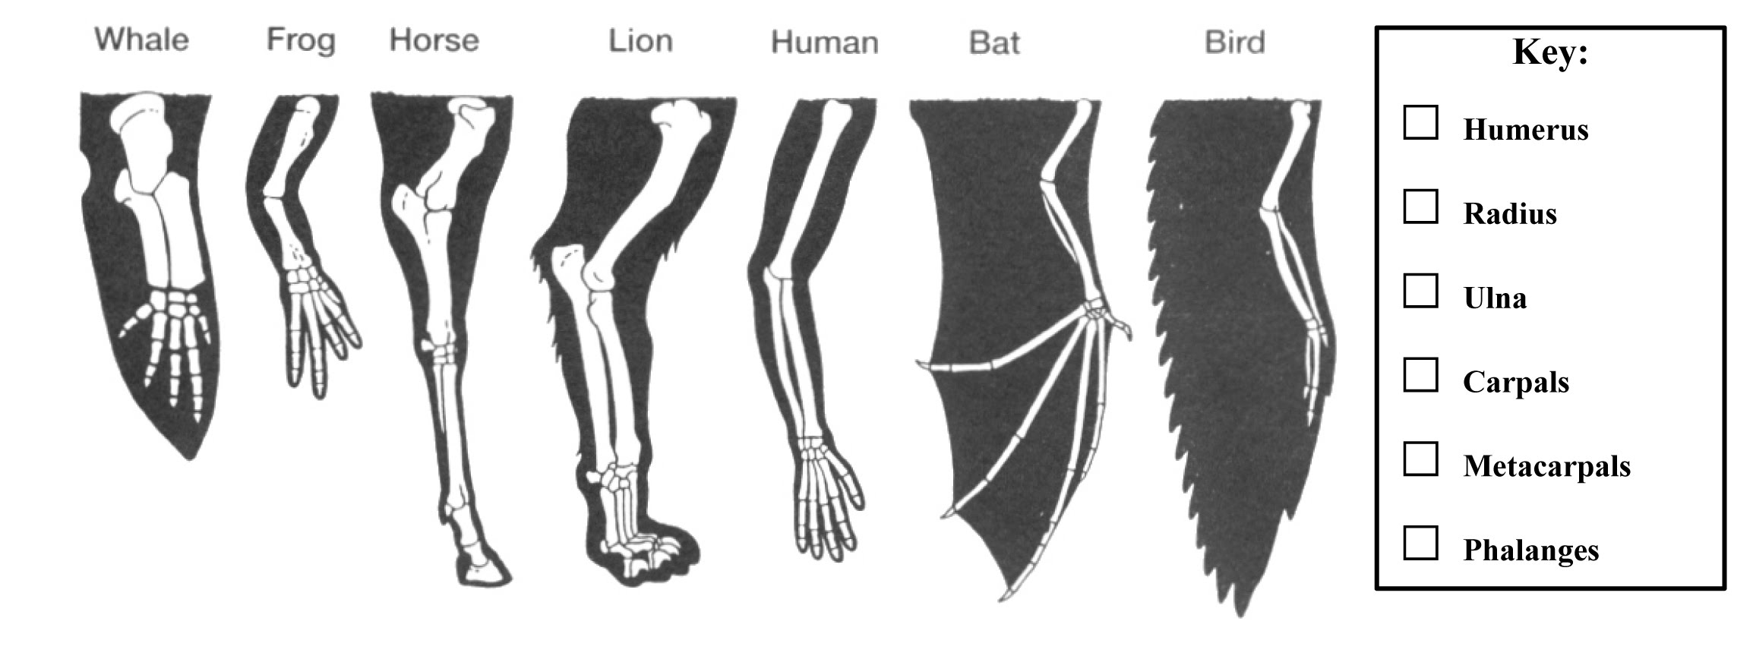

1. The name given to the type of evidence of evolution shown in the diagram is:
2. comparative embryology.
3. homologous structures.
4. vestigial organs.
5. analogous characteristics.
6. The best explanation for the evidence of evolution shown in the diagram is that:
7. the bird and the bat both use the limb as a wing to fly. The bird and the bat must have the more recent common ancestor than the other vertebrates.
8. all the limbs have evolved along different pathways, with the similarity due to coincidence. No relationship is supported by the evidence.
9. the highly-specialised limb of the horse makes it the most different from all the others. The horse must be the most distantly related to the other vertebrates.
10. all the limbs display a similar structure but function differently. All of these vertebrates must have shared a common ancestor at some point in time.

1. Artefacts differ from fossils in that artefacts:

(a) are found associated with human remains

(b) are made of organic material that can be carbon dated

(c) are objects produced by hominins for a particular purpose

(d) are works of art with religious significance

Question 4 refers to the diagram below of the half-life of Potassium (K)-40.

1. Potassium-40 decays into Argon-40. If a sample was found to be 3.2 billion years old, what approximate percentage of Argon-40 would be present?

(a) 80%

(b) 90%

(c) 60%

(d) 40%

1. The half-life of Carbon-14 is approximately:

(a) 10 430 years.

(b) 7250 years.

(c) 5730 years.

(d) 4780 years.

1. The following statements (not in correct order) summarise the steps in natural

selection.

*1. Some individuals are better suited to a particular environment.*

*2. Over time there is an increase in particular characteristics in the population.*

*3. There is variation within a population, some of which is genetic.*

*4. Individuals better suited to the environment are more successful at survival and reproduction.*

The order of statements which best describe natural selection are

1. 1, 3, 2, 4
2. 3, 1, 4, 2
3. 2, 3, 1, 4
4. 1, 2, 4, 3
5. In certain industrial parts of England a certain light coloured moth (*Biston betularia*) which normally invisible against the pale bark on the trees has now developed a very dark form of the species. This Dark coloured moth in a matter of a few years has become more successful than the light-coloured moth.

Which is the likeliest reason?

1. The dark moth no longer rests on trees but on dark rocks, also widely present in the moth's habitat.
2. Due to the local industry pollutants the trees have become soot-coloured.
3. The dark moth competes more successfully for food.
4. The dark moth breeds more rapidly than the light coloured moth.
5. How has the dark moth (mentioned in question 9 above) arisen in numbers?
6. By natural selection
7. By mutation
8. By geographical isolation
9. By adaptation.

Question’s 9 and 10 refer to the diagram of strata (layers) below.

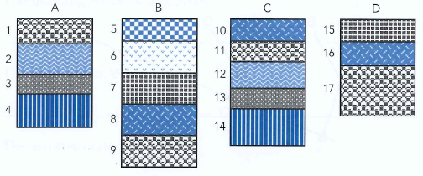

9. In which section would we find the oldest stratum (layer) at the surface?

(a) A

(b) B

(c) C

(d) D

10. Which of the following statements is **incorrect** concerning the above strata

(a) B8 is older than D15.

(b) A4 is the same age as C14.

(c) A1 is the same age as B9.

(d) D15 is younger than B6.

**End of Section A**

Name _________________________________________

Teacher_________________________________________

**SOUTHERN RIVER COLLEGE**

**Human Biological Science Unit 3 & 4**

**TASK 10 – Test 4 Evolution**

TOTAL / 50 MARKS

**Multiple choice & answer booklet**

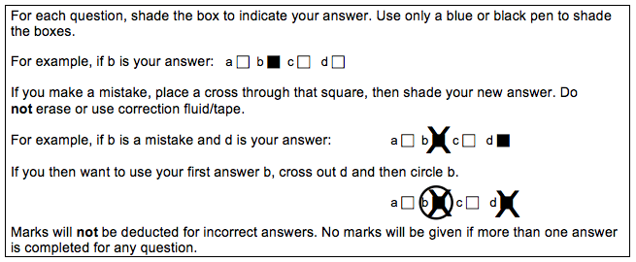

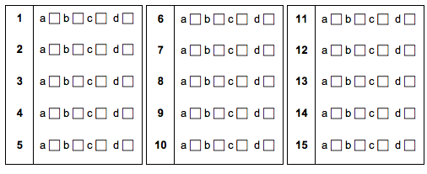

**Section B: Short Answer (30 Marks)**

Answer all questions in the spaces provided.

**Question 11 (9 marks)**

Part (a) of the question refers to the diagram below.



Coccyx

Appendix

Wisdom Teeth

The structures shown in the diagram provide evidence for evolution.

(a) (i) What collective name is given to the structures shown in the diagram?

(1 mark)

___________________________________________________________________

(ii) Provide another example of a structure in the human body that could be classified in the same category as those shown in the diagram.

(1 mark)

___________________________________________________________________

___________________________________________________________________

(iii) Explain how the structures shown in the diagram could provide evidence for evolution.

(3 marks)

___________________________________________________________________

___________________________________________________________________

___________________________________________________________________

___________________________________________________________________

___________________________________________________________________

___________________________________________________________________

Part (b) of the question refers to the diagram below.



(b) (i) What name is given to the type of evidence for evolution represented in the

diagram?

(1 mark)

___________________________________________________________________

(ii) Describe how the evidence shown in the diagram provides support for the theory of evolution.

(1 mark)

___________________________________________________________________

___________________________________________________________________

(iii) Could a similar diagram be drawn to include humans as an example in the same category as the three organisms shown in the diagram above? Justify your answer.

(2 marks)

___________________________________________________________________

___________________________________________________________________

___________________________________________________________________

___________________________________________________________________

**Question 12 (17 marks)**

The graph below indicates the temperatures at which different parts of the polymerase chain reaction (PCR) cycle occur.

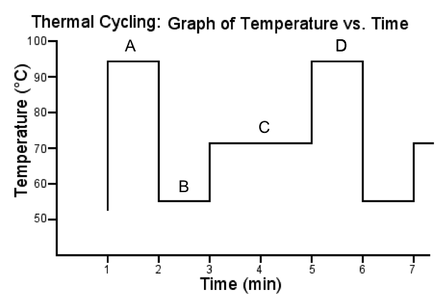

1. Give the names of each of the temperature phases as shown in the graph above:

(2 marks)

A ________________________ B ________________________

C ________________________ D ________________________

1. Why is the temperature required to be so high at section A on the graph?

(1 mark)

___________________________________________________________________

___________________________________________________________________

1. (i) What section of the graph is DNA polymerase involved in? (1 mark)

___________________________________________________________________

(ii) Is DNA polymerase the most appropriate enzyme? Explain why and include in your response what you would include instead. (2 marks)

___________________________________________________________________

___________________________________________________________________

(ii) Describe the role of DNA polymerase. (2 marks)

___________________________________________________________________

___________________________________________________________________

___________________________________________________________________

___________________________________________________________________

1. PCR and gel electrophoresis are used to assist in the identification of a crime suspect. Explain why you would require both of these processes in forensics.

(4 marks)

___________________________________________________________________

___________________________________________________________________

___________________________________________________________________

___________________________________________________________________

___________________________________________________________________

___________________________________________________________________

1. Explain how gel electrophoresis works. (5 marks)

___________________________________________________________________

___________________________________________________________________

___________________________________________________________________

___________________________________________________________________

___________________________________________________________________

___________________________________________________________________

___________________________________________________________________

___________________________________________________________________

___________________________________________________________________

**Question 13 (4 marks)**

There are many types of comparative studies that can be used to support the theory of evolution. Two of these involve studies in biochemistry, protein sequences and DNA.

Describe how protein sequences provide evidence for evolution.

___________________________________________________________________

___________________________________________________________________

___________________________________________________________________

___________________________________________________________________

___________________________________________________________________

___________________________________________________________________

**Section C: Extended Answer (10 Marks)**

Select ONE of the following questions, and answer below.

**QUESTION A**

Discuss the importance of the fossil record in providing evidence for evolution. In your answer, include how fossils form and how the information they provide can be interpreted. (10 marks)

**OR:**

**QUESTION B**

Describe how vaccines could be produced by recombinant DNA techniques.

(10 marks)